A Project report on
Light Fidelity (LiFi) - Wireless Optical Networking Technology

Name | Roll No | PRN No.
Rudraprasad Vishwamitre | 7049 | 22010802
Deep Jadhav (GR) | 7050 | 22010818
Dhaval Bora | 7062 | 22011010
Akshay Misal | 7064 | 22011042

Under the Guidance of
Prof. Chandrashekhar Garde.

In partial fulfilment for the requirement of PROJECT BASED LEARNING (F.Y. B. TECH)

Course-Engineering Physics Academic Year- 2020-21 Semester- I
Department of Engineering and Applied Sciences



VISHWAKARMA INSTITUTE OF INFORMATION TECHNOLOGY, PUNE

CONTENTS: -

- INTRODUCTION OF LIFI
- WORKING OF LI-FI
- LI-FI CONSTRUCTION
- COMPARISION OF LIFI WITH OTHER TECHNOLOGIES
- STANDARD FOR BLUETOOTH (IEEE 802.15.4)
- Standard for WIFI (IEEE 802.11b)
- Standard used for LIFI (IEEE 802.15.7)
- RF and Wavebands
- LiFi Wavelength Bands of operation
- Issues Regarding Radio-spectrum
- VLC over RF Communication
- WHY LIFI IS FASTER THAN WIFI?
- APPLICATION OF LIFI
- Technology for Industrial Automation System
- Road Traffic Management and Safety Using Li Fi Technology
- Other Application Areas of LiFi Technology
- CHALLENGING PROBLEMS
- SOLUTIONS TO CHALLENGING PROBLEM
- Solution for connectivity
- Solution for multiuser support
- Solution for shadowing
- REFERENCES
- CONCLUSION

INTRODUCTION OF LIFI

The Li-Fi (light fidelity) technology was proposed by the German Scientist namely Harald Haas. The main function of this technology is to transmit the data via light. This technology is idyllic for high speed wireless communication in a restricted region, and it offers many benefits over Wi-Fi technology such as high bandwidth, ease of use, efficiency, and safety. These systems can communicate from street lights to auto-piloted cars using their headlights. As the light speed is superior hence the data communication speed is also faster in the existing system. Furthermore, this technology can be implemented for speedy data access for the laptops, and gadgets that will be transmitted during the beam in a room.
Li-Fi-light fidelity is similar to Wi-Fi technology and it is one of the future wireless communication technologies. The main feature of this technology includes fully networked, bidirectional and high-speed wireless. Nowadays, the most trending domain in wireless communication is Wi-Fi and internet users are also being increased every year. The data transmission in this technology can be done using light because the light intensity changes quicker than the human eye for capturing. The range of data transmission in L-Fi is faster 100 times than Wi-Fi.

WORKING OF LI-FI

LiFi is high speed bidirectional networked and mobile communication of data using light. LiFi comprises of multiple light bulbs that form a wireless network
LED bulbs are semiconductor devices, which means that the brightness of the light flowing through them can be changed at extremely high speeds. This allows us to send a signal by modulating the light at different rates. The signal can then be received by a detector which interprets the changes in light intensity (the signal) as data. The intensity modulation cannot be seen by the human eye, and thus communication is just as seamless as other radio systems, allowing the users to be connected where there is LiFi enabled light. Using this technique, data can be transmitted from a LED light bulb at high speeds This brilliant idea was first showcased by Harald Haas from University of Edinburgh, UK, in his TED Global talk on VLC.
He explained,” Very simple, if the LED is on, you transmit a digital 1, if it’s off you transmit a 0. The LEDs can be switched on and off very quickly, which gives nice opportunities for transmitting data.” So, what you require at all are some LEDs and a controller that code data into those LEDs.
Further enhancements can be made in this method, like using an array of LEDs for parallel data transmission, or using mixtures of red, green and blue LEDs to alter the lightt’s frequency with each frequency encoding a different data channel. LED can be switched on and off to generate digital strings of 1s and 0s. Data can be encoded in the light to generate a new data stream by varying the flickering rate of the LED. To be clearer, by modulating the LED light with the data signal

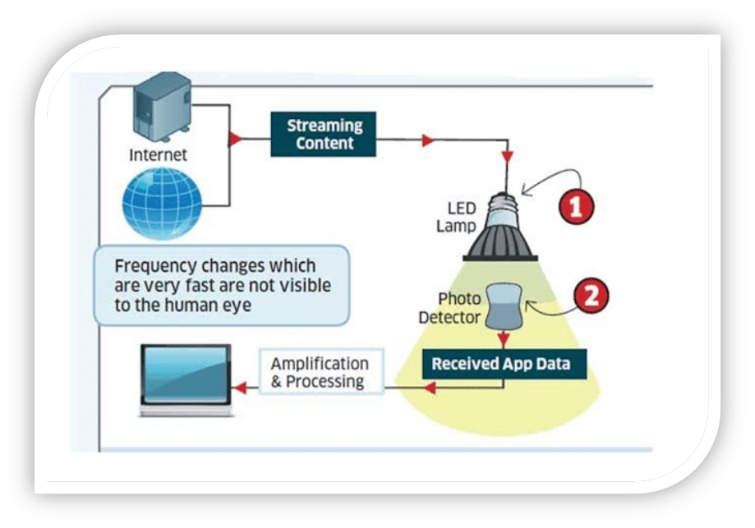
Working of li-fi

LI-FI CONSTRUCTION

The LI-F product consists of 4 primary sub-assemblies:

The PCB controls the electrical inputs and outputs of the lamp and houses the microcontroller used to manage different lamp functions. An RF (radio-frequency) signal is generated by the solid-state PA and is guided into an electric field about the bulb. The high concentration of energy in the electric field vaporizes the contents of the bulb to a plasma state at the bulb’s centre; this controlled plasma generates an intense source of light.
All of these subassemblies are contained in an aluminium enclosure.

Transmitters:
The following components are used at the transmitting side:

- Coloured LEDs
An array of Red, Green and Blue LEDs are used at the transmitter end as visible light sources. They are connected as loads in the transistor circuitry. They are high power and emit a focused beam. Each colour is used to carry a different data stream.

- MOSFETs
A high-speed N-type power MOSFET IRF 520 is used to modulate the LEDs using OOK (On off Keying). The serial output from the computer is converted into TTLCompatible form and is then applied to the gate of the transistor. Thus, it switches the load (LEDs) on and off in accordance with the input data 4.3.1.3 RS232 line driver Since the output of computer is RS232 compatible, a 16 pin RS232 line driver ICMAX 232 is used to make the computer output TTL level compatible to drive the transistor circuit carrying through LED load.

- USB to RS232 converter cable
In laptops, serial port is not available. Since data is to be transmitted serially between the two computers, a USB to RS232 converter cable is used to interface the serial output from MAX 232 IC to the laptop using the built-in USB port. This cable contains an embedded controller to conform the RS232 compatible data into USB protocol compatible form.

- Voltage Regulator
A voltage regulator is used to supply constant voltage (5V) to MAX232 IC. A 3 pin7805 IC is used to serve the purpose

Receivers:
The following components are used at the receiving side:

- Optical Receiver
A 6-pin fibre optic receiving module TORX 173 is used as the light sensing device. On receiving light pulses, it gives a high output whereas the output goes low in the absence of light.

- Optical Filters
Red, green and blue light filters are used at the receiver to de multiplex the multiple data streams. These are sharp narrowband filters. A red-light filter allows the frequency band corresponding to red colour to pass through it and blocks all other wavelengths. Thus, when a red-light filter is placed in front of the optical receiver, only the data stream carried by the red beam falls at the receiver while the other streams are blocked. Similarly, blue or green light filters can be used to allow the desired data stream to reach the receiver.

- Voltage Regulator
A voltage regulator is used to supply constant voltage (5V) to TORX 173.A 3 pin7805 IC is used to serve the purpose.

- RS232 line driver
Since the output of TORX 173 is TTL level compatible, a 16 pin RS232 line driver IC MAX 232 is used to make the output RS232 compatible so that the receiving module can be interfaced to the computer.

- USB to RS232 converter cable
In laptops, serial port is not available. Since data is to be transmitted serially between the two computers, a USB to RS232 converter cable is used to interface the serial output from MAX 232 IC to the laptop using the built-in USB port. This cable contains an embedded controller to conform the RS232 compatible data into USB protocol compatible form the most common choice of receivers are photodiodes which turn light into electrical pulses. The signal retrieved in this way can then be demodulated into actual data.

COMPARISION OF LIFI WITH OTHER TECHNOLOGIES

Comparison of LiFi with other Technology In general Bluetooth & WIFI are frequency base while LiFi in LiFi Light is basis which has no frequency range, both Bluetooth & WIFI are range restricted but LiFi is based on LED light falling primary application In Bluetooth is WPAN, in WIFI WLAN for LiFi where ever life light is available in the data transfer rate Bluetooth has speed of 100kb/ps, WIFI has 11 Mbps but. LiFi has Greater than 1 Gbps. LiFi requires low power consumption with high security than other two comparable techniques Now, for further divisions in Standards

- STANDARD FOR BLUETOOTH (IEEE 802.15.4)

IEEE 802.15.4 is a technical standard which defines the operation of low-rate wireless personal area networks (LR-WPANs). It conformant devices may use one of three possible frequency bands for operation (868/915/2450 MHz).
the definition of the network layers is based on the OSI model; although only the lower layers are defined in the standard, interaction with upper layers is intended, possibly using an IEEE 802.2 logical link control sublayer accessing the MAC through a convergence sublayer.

- The physical layer:
The physical layer is the bottom layer in the OSI reference model used worldwide, and protocols layers transmit packets using it the physical layer (PHY) provides the data transmission service. It also, provides an interface to the physical layer management entity, which offers access to every physical layer management function and maintains a database of information on related personal area networks.

- The MAC layer:
The medium access control (MAC) enables the transmission of MAC frames through the use of the physical channel. Besides the data service, it offers management interface and itself manages access to the physical channel and network beaconing.
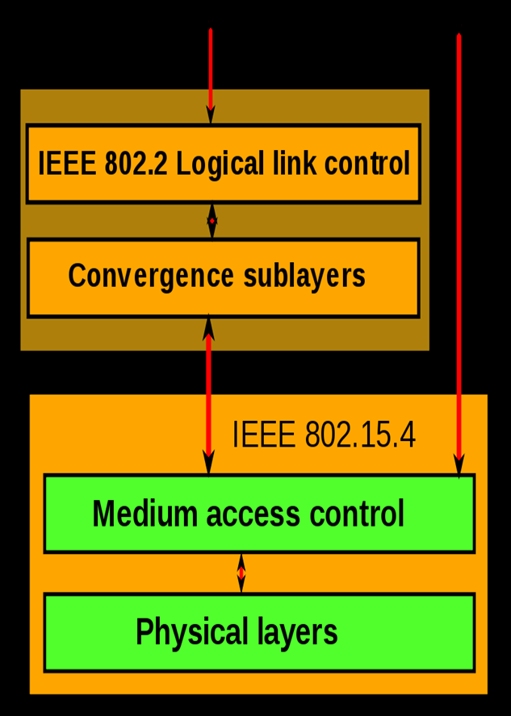
Standard for Bluetooth (IEEE 802.15.4)

- STANDARD FOR WIFI (IEEE 802.11B)

IEEE 802.11 wireless networking specification that extends throughput up to 11 Mbit/s using the same 2.4 GHz band they are commonly used today in their 802.11a, 802.11b, 802.11g, 802.11n, 802.11ac and 802.11ax versions to provide wireless connectivity in the home, office and some commercial establishments.802.11b products appeared on the market in mid-1999, since 802.11b is a direct extension of the DSSS (Direct-sequence spread spectrum) modulation technique defined in the original standard.802.11b devices suffer interference from other products operating in the 2.4 GHz band. Devices operating in the 2.4 GHz range include: microwave ovens, Bluetooth devices, baby monitors and cordless telephones.
Interference issues and user density problems within the 2.4 GHz band have become a major concern and frustration for users.
Different versions of Wi-Fi use different techniques, 802.11b uses DSSS on a single carrier, whereas 802.11a, Wi-Fi 4, 5 and 6 use multiple carriers on slightly different frequencies within the channel

- STANDARD USED FOR LIFI (IEEE 802.15.7)

The figure depicts protocol stack used in a typical VPAN device. As shown protocol stack consists of PHY, MAC and upper layers.
Physical layer houses light transceiver. PHY switch housed in PHY layer interfaces with optical SAP which connects it to the optical medium. The optical medium composed of one or multiple optical sources or optical detectors (e.g. laser diodes or photodiodes).
MAC layer provides channel access for all types of data and control message transmissions. Upper layer consists of network layer and application layer. Network layer takes care of providing network configuration, network manipulation, message routing etc. Application layer takes care of providing intended functionality as needed by the VPAN or LiFi device.
DME (Device Management Entity) is also supported by LiFi or VPAN network architecture. It makes interfacing between dimmer and PHY/MAC a reality.

- LiFi PHY:

There are three types of physical layer configurations supported in VLC or LiFi System Viz.
- The PHY I- was established for outdoor application and works from 11.67 Kbit/sto 267.6 Kbit/s.
- The PHY II- layer allows to reach data rates from 1.25 Mbit/s to 96 Mbit/s.

- The PHY III- is used for many emissions sources with a particular modulation method called color shift keying (CSK). PHY III can deliver rates from 12Mbit/s to 96 Mbit/s.
The modulations formats recognized for PHY I and PHY II are the coding on-off keying (OOK) and variable pulse position modulation (VPPM). The Manchester coding used for the PHY I and PHY II layers include the clock inside the transmitted data by representing a logic 0 with an OOK symbol "01" and a logic 1with an OOK symbol "10", all with a DC component. Importantpoint because the DC component allows to avoid the light extinction in case of anextended line of logic 0. The Li-Fi Consortium has also been established to work on standardizing VLC communications, but the rapid evolution of the technology minimizes the impact of any standardization effort.
Different rates can be achieved in different configurations. They can be used indoor or outdoor.

- LiFi MAC:

MAC layer takes care of resource management i.e. allocation of channels, IDs as well as entire network management.

- LiFi Modulation Types-

OOK, VPPM, CSK: There are different modulation schemes used in different physical layer modes. OOK stands for On Off Keying, VPPM stands for Variable Pulse Position Modulation and CSK stands for Colour Shift Keying.

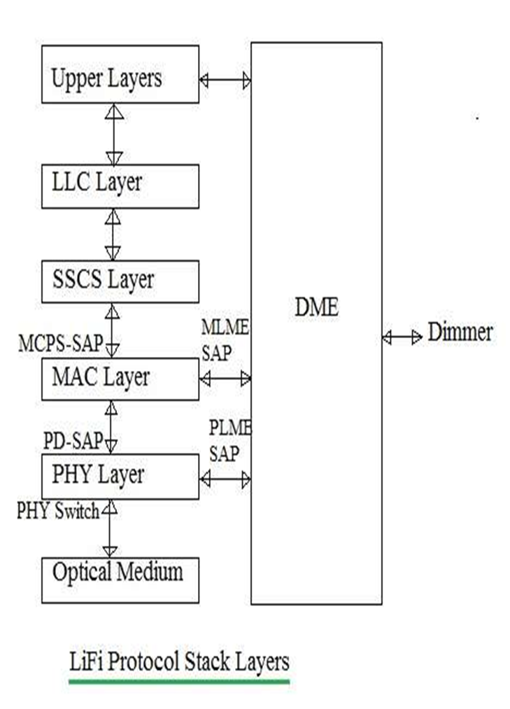
Standard used for LiFi (IEEE 802.15.7)

- RF and Wavebands

Wireless networking is an RF (radio frequency) technology. Air is the vehicle through which the data is carried, just as Ethernet uses copper cables. WLAN frequency ranges are in the 2.4GHz and 5GHZ bands. The most common legacy wireless standards, 802.11b and 802.11g, use the 2.4GHz range. IEEE 802.11a uses 5GHz exclusively. The newer 802.11n operates mostly in 5GHz but can also use the 2.4GHz band.
The forthcoming 802.11ac standard operates in 5GHz. Hence Frequency of operation2.4GHz, 4.9GHz and 5GHz mostly WIFI supports different speeds and coverage ranges as per implemented standard in the devices (STAs, APs).

- 802.11a supports up to 54 Mbps,
- 802.11b up to 11 Mbps,
- 802.11n supports 72 Mbps/150 Mbps as per BW (20MHz/40MHz),

The distance coverage of 70 meters (indoor) to 250 meters (outdoor) can be achieved.

In WIFI, RF signal passes through the walls and hence there is a need to employ techniques to achieve secure data transfer.
Coverage distanceAbout 32 meters (WLAN 802.11b/11g), vary based on transmit power and antenna type

- LiFi Wavelength Bands of operation

LiFi standard compliant device operates from 380 nm to 780 nm wavelength region. This device operates on one or multiple visible light frequency bands.
The LiFi bands with spectral with and possible code combinations used are mentioned in the table below.
It uses light with wavelength ranging from 380 nm to 780 nm for data communication between LEDs and photo detectors Present IrDA compliant devices In LiFi, light does not pass through the walls and hence will provide a much secure data transfer data transfer rate is about 1 gbps Frequency of operation10 thousand times frequency spectrum of the radio Data density Works in high dense environmentCoverage distance About 10 meters

ISSUES REGARDING RADIO-SPECTRUM

● Data Density:
The radio spectrum Works in less dense environments due to interference related issues.

● Efficiency:
Millions of base stations for radio wave transmission and receiving on the earth consume huge amount of energy for transmitting the radio waves and to cool the base station cabins. It gives only 5% Efficiency. In case of LI-FIit does not consume energy as compare to other waves. It is very cheap.

● Availability:
Radio waves are available within the range of Base stations which make it limited availability. It is unavailable in aircrafts because of interference of wave cause crash. But LI-Fi does not produce interference and provide user a perfect communication channel for accessing internet telephone, watching movies online.

● Security:
Radio wave penetrates walls which cause security laps. Any one access to the private network of any one and use their data, login to their secure region

● Loading speeds:
Loading speeds are comparatively very low nearly 150 mbps

● Banned in Sensitive Areas:
The radio wave cannot be used in hospitals and Space stations because it adversely acts the performance of precision instruments.

VLC OVER RF COMMUNICATION

● Availability of high bandwidth
With everything going wireless, we’ve been hurtling towards a wireless crunch, where available bandwidth just won’t be able to keep up with user demand. And while VLC certainly won’t stop this from happening, it will buy us time. The bandwidth frequency spectrum of visible light is larger than that of RF bandwidth. VLC bandwidth ranges from 430 THz to 750 THz, and RF frequency offers a bandwidth range from 3 kHz to 300 GHz.
Operating on different bandwidths will also open up the possibility of using VLC in environments like airplanes and hospitals, where traditional data transmission would have interfered with communication.

● Efficiency and security
VLC could be a boon for secure communications.
Since light can’t travel through solid objects, information transmitted via VLC can only be accessed if the receiver is in the same room. This has some very obvious security benefits, and this is expected to drive the development of the technology over the forecast period.
And on top of being secure, using LEDs for both data transmission and lighting is pretty efficient. That being said we’re still ways away from exclusive Li-Fi. Most buildings are already Wi-Fi enabled, and hybrid systems are a much more realistic situation for the near future. However, LEDs are relatively cheap, consume negligible power, and are already present almost everywhere, which would make a (hypothetical) transition to Li-Fi achievable.

● Unlicensed use, high data density, and data rates
Visible light communication uses a spectrum that is abundant, free and has no regulations (so far) when compared to the radio spectrum. This allows a user to choose any frequency to transfer information, thus eliminating licensing issues.
Moreover, Li-Fi achieves a much higher data density than Wi-Fi, since light can be contained in a specific area. Additionally, low interference, along with high-intensity optical output help achieve high data transfer rates.
All of this translates to quicker, easier communication.

WHY LIFI IS FASTER THAN WIFI?

The data transfer rate depends upon the frequency of the carrier as the data transfer can be a maximum of 1/2 frequency of the carrier frequency. (Nyquist rate)Visible light communication (VLC) is a data communication method that uses visible light between 400THz and 800THz (Tera-Hertz) frequency; wavelength is 780nm to 375nm. It is a subset of optical wireless communication technologies.
The most fundamental property of any spectrum to provide fast data rates is the bandwidth that it can offer. According to the Shannon Hartley theorem, channel capacity C is directly proportional to the bandwidth B of the channel.

C=Blog2(1+S/N)

Where S/N is the signal to noise ratio of the channel, B is the bandwidth in Hz, and C is the information rate in bits/second. This result assumes Gaussian white noise. Thus, if you take a look at the radio frequency spectrum used for WIFI spectrum, you will notice that channel bandwidth ranges from 20 MHz (802.11b), 40 MHz (802.11n) and 80-160 MHz (802.11ac).
However, visible light spectrum bandwidth is far greater than that of radio spectrum. A short look up on the web will tell you that the bandwidth for visible light is on the order of several Terahertz, which is 6 orders of magnitude greater than the radio frequency spectrum. And so, with larger bandwidth comes faster data rates, thus LiFi is able to provide faster data rates than WIFI even though both are electromagnetic radiations.

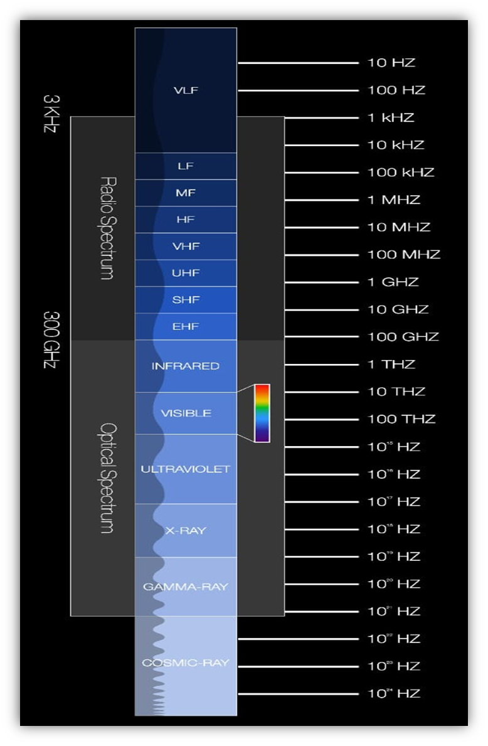

Electromagnetic Spectrum

APPLICATION AREAS OF LIFI

Application of LiFi technology for industrial automation system

We can design the monitoring and control system for the Industrial parameter using the LiFi communication technology Monitoring is most important in industry. Monitoring is done by sensor with most accuracy and reliability.
Control process will also be handled by this LIFI communication. Arduino decodes the commands are given through LIFI with the help of LED and control the industrial devices through relays. The interfacing between LIFI transmitter and LIFI receiver is done by Arduino. This concept was taken to reduce human efforts in industry.

- Working:

Input such as sensor, current sensor, temperature sensor, gas sensor is given to ARDUINO development board. LIFI is used to send a message through LED bulb. LIFI provides uninterrupted output. This application is developed for monitor and control the machine health in industry. In existing project WIFI concept is used which is high cost and data transfer speed is 150Mbps. WIFI is difficult to transmit message to long range.
The applicability of LIFI concept is implement in industrial sector itself both monitor and control the machine health. LIFI is cheaper than WIFI because free band does not need license and it uses light.

The hardware consists of various components such as:

- ARDUINO UNO at mega 328
- Relay,16*2 LCD
- voltage sensor
- Current temperature sensor
- Gas sensor
- LIFI transmitter, photo detector (LIFI receiver),
external device (power distributor) DC supply of 5v

Road Traffic Management and Safety Using Li Fi Technology

Proposed application of VLC includes use of Li Fi technology at traffic signals and at toll plazas. The system uses a toggling LED at transmitting end and a photodiode at receiving end.
LEDs are used to transmit the data at transmitting end. At receiving end, a photodiode is connected to PC which senses the transmitted data and feed it to the PC. A PIC microcontroller can be used for toggling of LED at transmitting end.
At receiving end also, one has to use a PIC microcontroller connected to output of photodiode. The light received by photodiode is converted to binary data and is fed to the microcontroller. The microcontroller is connected to the serial port of the PC

- Working

One can make use of head lights and tail lights of vehicles. As every vehicle has assigned on number, one unique code is assigned to every vehicle. The head light and tail light transmit this code after a regular interval. When the vehicle passes through the toll plaza, the code is sent to the PC at toll plaza. Complete information about your vehicle is then displayed on the pc. Traffic police can make use of this information if required. Person then pays the toll (Road Service Tax) and move ahead. Thus, information about each and every vehicle passed, Number of vehicles passed in one day and total service tax collected is recorded in central server of such road service tax system. The complete system thus becomes transparent to a common tax payer. All the computers at all toll plazas are networked together. Thus, they can share the required information about each and every vehicle.
The same system can be used for creating green corridor to the emergency vehicle. Here, the signal transmitted by the emergency vehicle is send to a photodiode. The output of the photodiode is applied to the microcontroller which drives the signal lights for fixed time duration. When signal transmitted by the emergency vehicle overrides this signal, the signal turns green and remains green till the vehicle is passed. Once the vehicle is passed the microcontroller again switches to its normal mode of operation. Thus, as the emergency vehicle passes ahead, it will make the signal green creating Green Corridor for it

Some other Application Areas of LiFi

● Aviation
Efficient communication of data is possible in airborne environments such as a commercial passenger aircraft utilizing Li-Fi. Using this light-based data transmission will not interfere with equipment on the aircraft that relies on radio waves such as its radar.

● Underwater communication
Radio waves are quickly absorbed in water, preventing underwater radio communications, but light can penetrate for large distances. Therefore, LiFi can enable communication from diver to diver, diver to mini-sub, diver to drilling rig, etc.

● Hospital
Hospitals are a specific case of an environment where both EMI sensitivity and security of data are issues. LiFi can enable the better deployment of secure networked medical instruments, patient records, etc.

● Internet anywhere
street lamps, light of vehicles can be used to access internet anywhere in footpaths, roads, malls, anywhere

CHALLENGING PROBLEMS

- Connectivity while moving

- Multiuser support

- Shadowing

SOLUTIONS TO CHALLENGING PROBLEMS

- Solution for connectivity

This problem is similar to the connectivity problem in cellular network when you move from one area of the city to another area while speaking with cell-phone. The solution is called “handover”, using which the user is transferred from one BS to another Handover is done in the area that two BS’s have common coverage. Similar solution can be used in signal processing domain for VLC. The user can be transferred from one light source to another in the area that is under the coverage of both

- Solution for multiuser support

In this problem one solution is time division multiplexing (TDM). Each frame is divided into equal time slots. Each user transmits data in one time slot in a predefined order. The other solution is code division multiple access (CDMA). Codes are assigned to users. Each user transmits its data using the assigned signature pattern. It is used in 3G and 4G cellular networks. CDMA has been adopted and developed for optical systems. Optical orthogonal codes (OOC) are used as signature pattern for users.

- Solution for shadowing

When the line-of-sight (LOS) part (which is received via direct path) is blocked, the impulse response is only the second part.
Then the data can be recovered using the second part which is indeed the received data from the indirect paths (multipath signal)

shadowing
CONCLUSION

The possibilities are numerous and can be explored further. If his technology can be put into practical use, every bulb can be used something like a Wi-Hotspot to transmit wireless data and we will proceed toward the cleaner, greener, safer and brighter future. The concept of Li-Fi is currently attracting a great deal of interest, not least because it may offer a genuine and very efficient alternative to radio-based wireless.
As a growing number of people and their many devices access wireless internet, the airwaves are becoming increasingly clogged, making more and more difficult to get a reliable, high-speed signal. This may solve issues such as the shortage of radio-frequency bandwidth and also allow internet where traditional radio-based wireless isn’t allowed such as aircraft or hospitals. One of the shortcomings however, is that it only work in direct line of sigh ere where light source is available.

REFERENCES

- https://www.irjet.net/archives/V5/i2/IRJET-V5I260.pdf
- https://lifi.co/what is LiFi%20is%20a%20wireless%20optical,radio%20waves%20to%20transmit%20information
- https://lifi.co/what-is-lifi
- LiFi tutorial-LiFi network,protocol,PHY,MAC,bands,modulation (rfwireless-world.com)
- Li-Fi – Wikipedia
- www.rfwireless-world.com
- electronicslovers.com

